Week 6
Hands-on with HBase

Objective 1 - Conceptual Foundations
HBase is a NoSQL database built on top of Hadoop HDFS and modeled after Google’s Bigtable. While HDFS and Hive are optimized for batch analytics and large sequential scans, they are not designed for low-latency access. HBase fills this gap by supporting fast, random reads and writes of individual rows, typically in milliseconds. The HBase Master acts as the control plane, managing metadata and assigning regions to RegionServers to balance load, while RegionServers handle client read and write requests. As tables grow, HBase automatically splits them into multiple regions and distributes those regions across different worker nodes in the cluster.
HBase is a wide-column store, where data is organized into tables, rows, and column families. Columns within the same column family are stored together on disk, which makes access patterns critically important to performance. Unlike Hive, which provides an SQL-like interface for analytical queries, HBase is designed for applications that need sub-second lookups across very large datasets. Row key design is central to HBase performance: poorly designed keys can create hotspots where a single RegionServer becomes overloaded. Sequential row keys such as timestamps or auto-incrementing integers are common anti-patterns, while well-designed keys intentionally spread traffic across regions, often using hashing or salting techniques.
Unlike traditional relational databases, which enforce strong consistency and fixed schemas for transactional workloads, NoSQL systems like HBase relax some relational guarantees to scale horizontally. HBase excels when applications require flexible schemas and real-time access to large volumes of data. It is not intended to replace analytical systems like Hive for long-term data exploration or large aggregations. Instead, HBase is best viewed as an operational data store, optimized for fast point lookups and high-throughput access patterns rather than complex analytical queries.

Objective 2 – HBase Table Creation and Management
The students table was created successfully with a single column family named details. The output confirms that HBase accepted the create command and initialized the table without any errors.
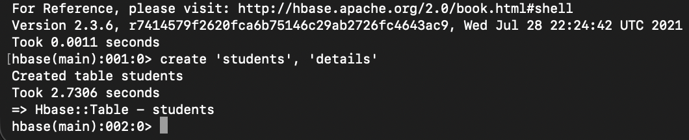
The list command displays all tables currently available in HBase. The output confirms that the students table exists and is accessible.
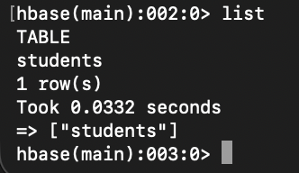

Objective 3 – HBase Data Manipulation
A new row with row key 1 was inserted into the students table by adding firstName and lastName columns under the details column family. This confirms that data can be written to the table successfully using put commands.
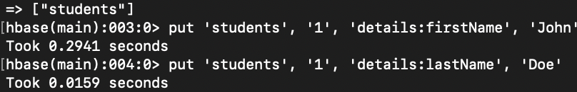
The get command retrieves the row with ID 1 from the students table and displays the stored firstName and lastName values. The output confirms that the data inserted earlier was written correctly and can be read back from HBase.
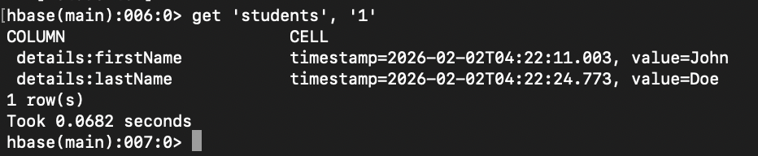

Objective 4 – Composite Row Keys with HBase
A new table named orders was created with a column family called orderDetails. The output confirms that the table was successfully created and is now available for storing order-related data.
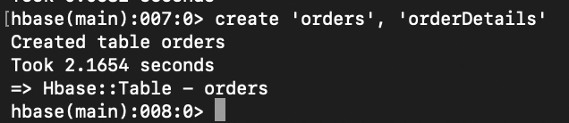
Two rows were added to the orders table using composite row keys that include an order ID and date. Each row stores an item value under the orderDetails column family, demonstrating how composite keys can be used to organize and insert order data in HBase.
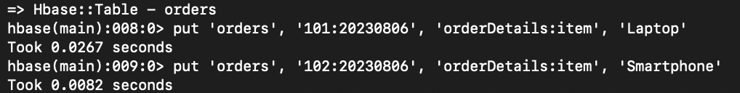

Objective 5 – Data Generation in HBase
Student records with IDs 2 through 100 were populated in the students table by inserting firstName and lastName values following a consistent naming pattern. This was done to quickly generate sample data for testing and later modification operations.
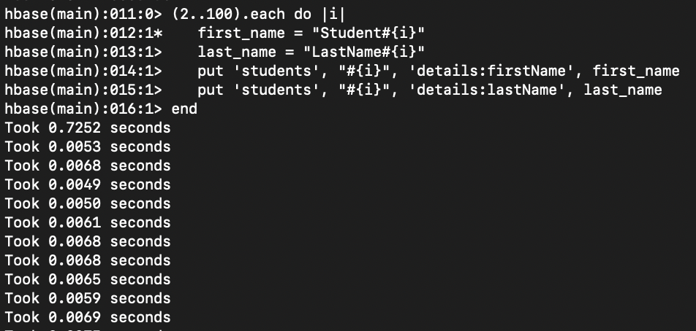
The scan command lists all rows in the students table along with their stored firstName and lastName values. The output confirms that multiple student records were successfully inserted and that the table contains data across a wide range of student IDs.

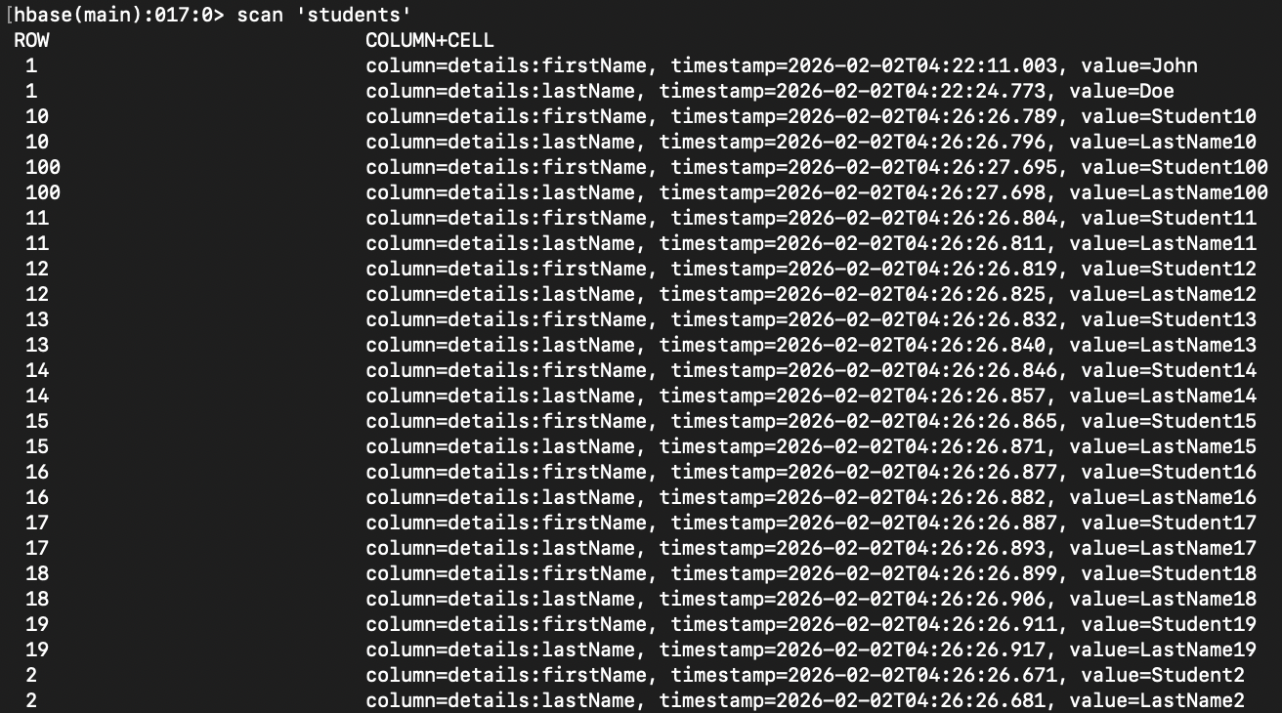

Objective 6 – Advanced Data Manipulation in HBase
The loop iterates over student IDs 2 through 50, reads each student’s firstName, and replaces the prefix Student with Scholar when present. This updates the firstName values to reflect the new naming convention for that range of students.
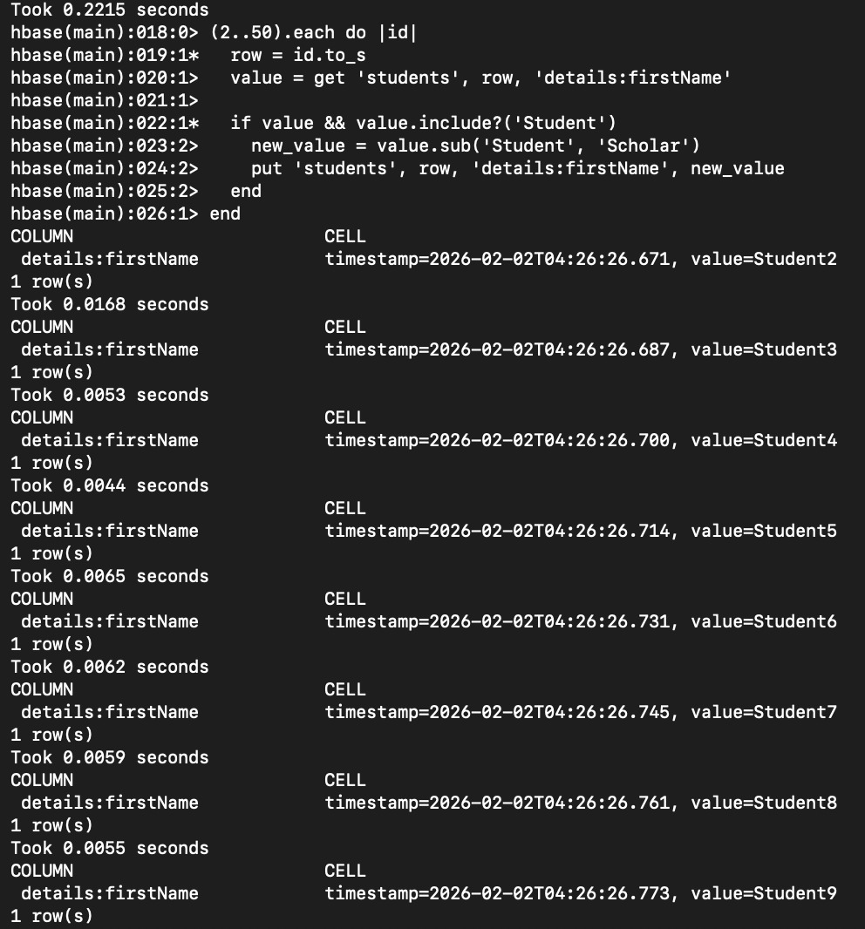
A new middle_name column was added under the details column family for students with IDs 51 through 75, with values following the pattern MidName followed by the student ID. This was done to demonstrate how HBase allows new columns to be added dynamically without altering the existing table schema.
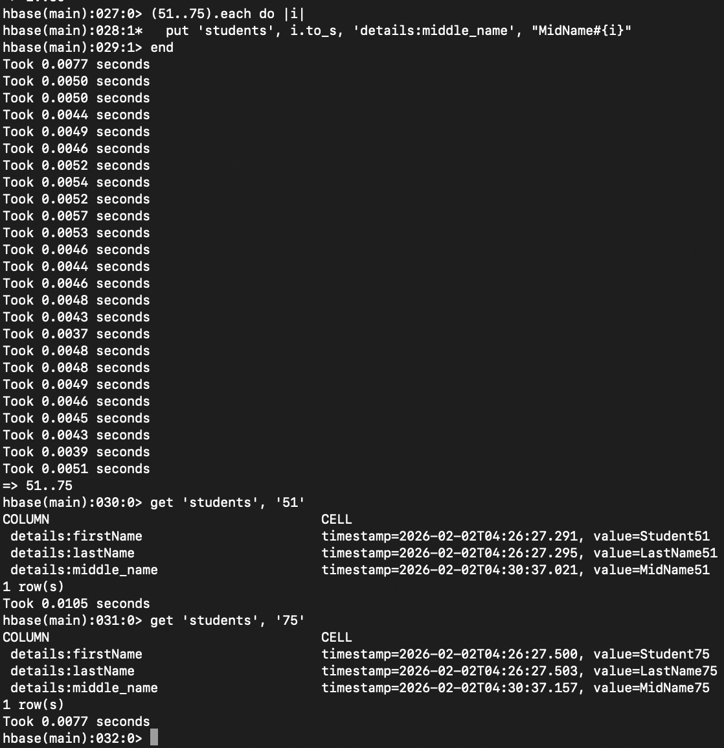

This shows a loop in the HBase shell that iterates over student IDs 76 through 100 and updates each student’s last_name by appending the suffix _Modified. For each row, the existing last_name value is read and then written back as a new version with the modified value.

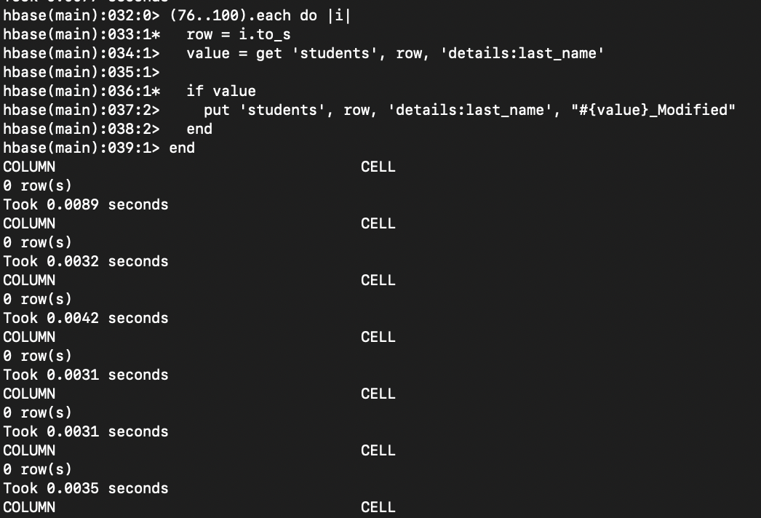
This screenshot shows student 76 before and after updating the last name, where a new last_name value with the suffix _Modified was added under the details column family. No data was removed; instead, a new version of the last_name column was written, and the previous value remains as an older version in HBase.
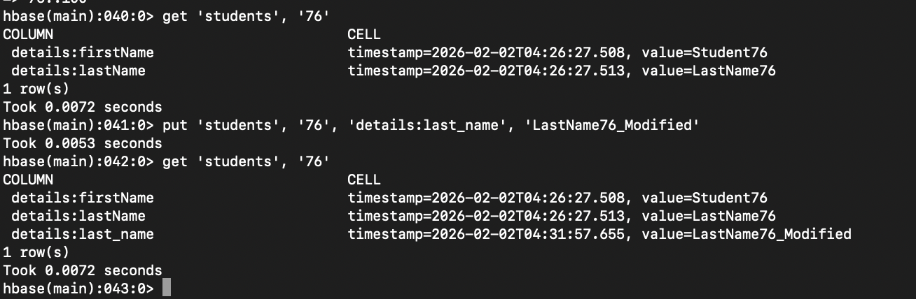

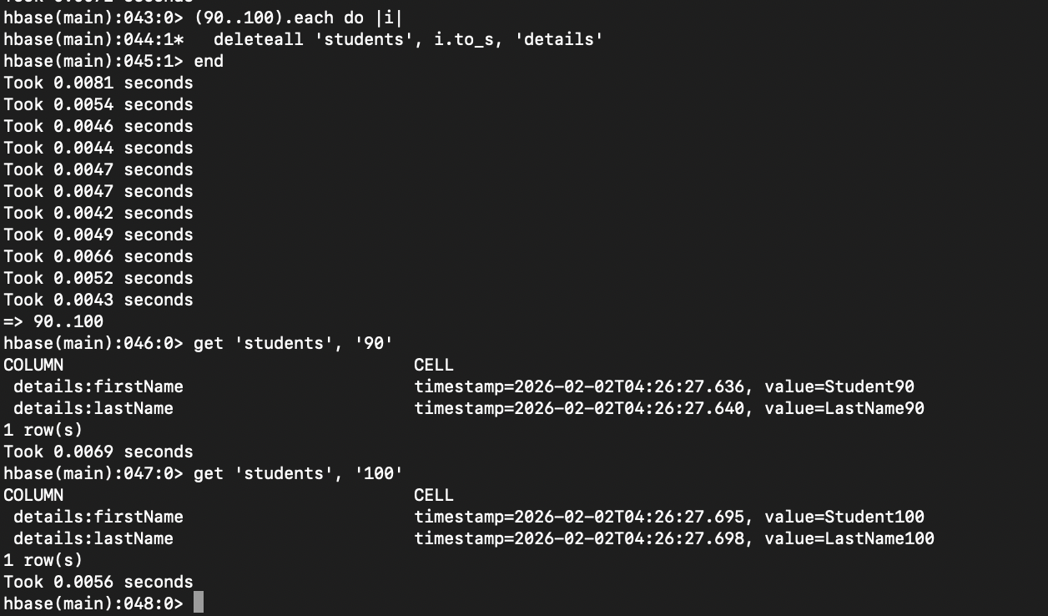
This screenshot shows the results of running HBase get commands to retrieve the details column family for students with IDs 40, 60, 80, and 90 after performing the updates. The output verifies that student 60 includes a middle_name column, while the resulting rows display the current first and last name values stored for each student.

